Functional Specification for the FlyAway Booking Portal

This assessment project was implemented using the following technology artifacts:

1. Backend: The backend models comprises of Hibernate entities, DAOs, and MySQL database for storage.

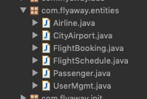

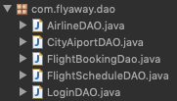

1. Business Logic: The logic is implemented using the Java Servlet (controllers), Service Layers, and POJOs

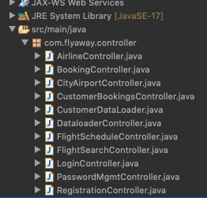



1. Front end: The views are implemented with JSP with some bootstrap inclusion.

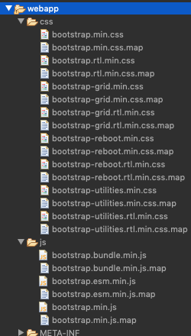

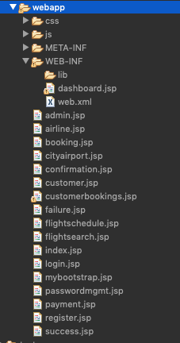

Build / Run:

Compiling / building the application requires maven to be available on the local machine.

From the project folder, run the following maven goals:

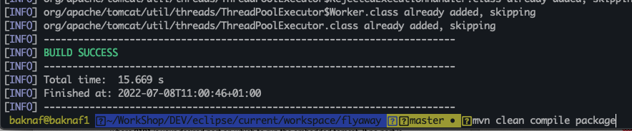

During the first-run, the launcher will require the tomcat port for the embedded tomcat server for a successful start as shown here:

Project folder: > java -jar ./target/flyaway-jar-with-dependencies.jar 9191

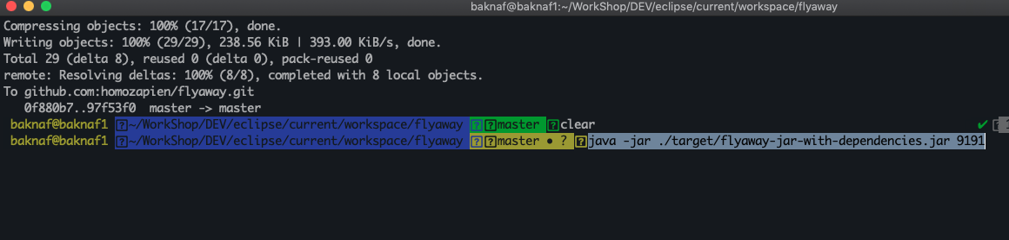

where 9191 is your desired port on which to run the embedded tomcat. If no port is specified from the command line, default of 8181 will be used.

Database:

The hibernate config file is defined as thus:

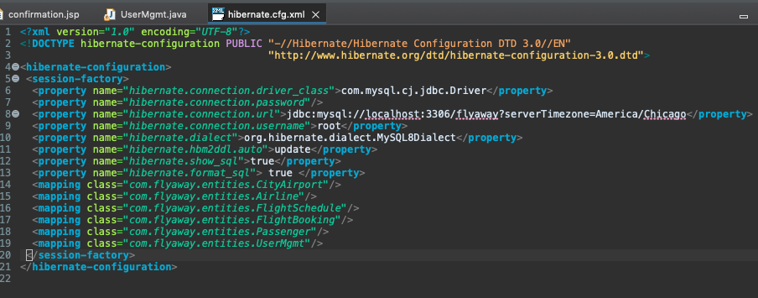

The database name to be created in mysql is: flyaway

All mapped entities (i.e. tables) will be created in this database.

The hibernate entities class will be created automatically including but not limited to the “UserMgmt.java” class. The class will store the admin username and password as shown here:

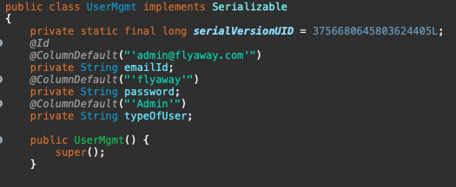

The default admin userId is: [admin@flyaway.com](mailto:admin@flyaway.com) and password: flyaway. In the event that this default values are not created automatically by hibernate, do run this manual command:

Mysql prompt > Use flyway; //change to flyaway db

Insert into usermgmt (“emailid”, “password”, “typeofuser”)

Values (‘admin@flyway.com’, “flyaway”, “Admin”)

Note: You may change the admin password with the application

Note: This application only allows use to create one passenger per booking, future enhancement will allow for multi-passenger booking

Thank You.